

|  |  |  |  |  |  |
| --- | --- | --- | --- | --- | --- |
| Programme | : | **B.Tech.** | Semester | : | **Fall 22-23** |
| Course | : | **CSE3002:**  **Internet and Web Programming Lab** | Slot | : | **L9+L10** |
| Faculty | : | **Dr. M. Premalatha** | Marks | : | **10** |

**Date: 06-09-2022**

**Advait Deochakke**

**Exercise –6**

HTML – **Javascript**

**Note:**

1. **View your registration number in the title bar and snap a screenshot of output along with the title bar.**
2. **Screenshot is required for every modifications of the web page.**
3. Write a JavaScript to
4. Create a dynamic table with two rows and two columns
5. Change the color of the Button from red to green color on Mouse Over.
6. Change the color of the Textbox from green to yellow color on Focus and display a greeting message on Change

**Note:** Both button and textbox should be created using CreateElement

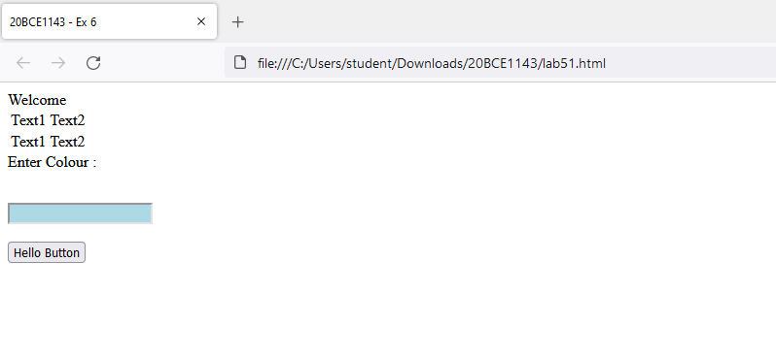

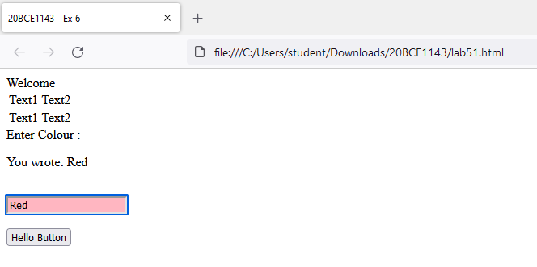

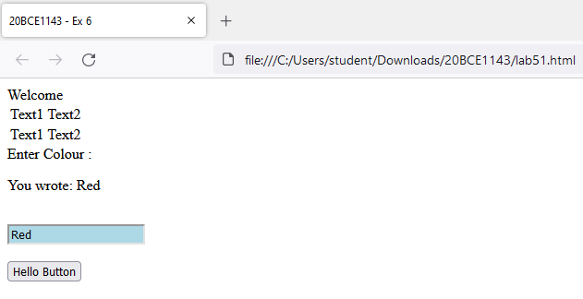

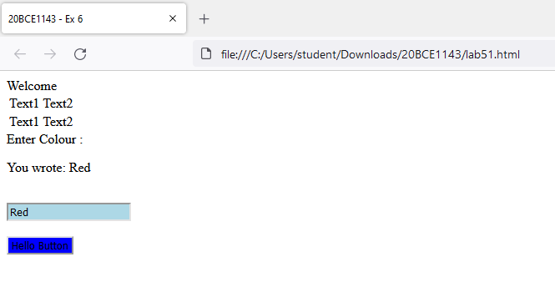

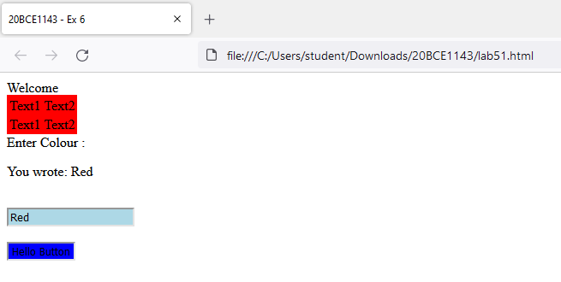

Code:

<head>

    <title>20BCE1143 - Ex 6</title>

    <style>

        input{

            background-color: lightblue;

        }

        input:focus{

            background-color: lightpink;

        }

    </style>

</head>

<body>

    Welcome

    <br>

    <script>

        var table = document.createElement('table');

        table.id="mytable";

        for (var i = 1; i < 3; i++){

            var tr = document.createElement('tr');

            var td1 = document.createElement('td');

            var td2 = document.createElement('td');

            var text1 = document.createTextNode('Text1');

            var text2 = document.createTextNode('Text2');

            td1.appendChild(text1);

            td2.appendChild(text2);

            tr.appendChild(td1);

            tr.appendChild(td2);

            table.appendChild(tr);

        }

        document.body.appendChild(table);

    </script>

    Enter Colour : <br>

    <p id="demo"></p>

    <br>

    <script>

        const tbx = document.createElement("input");

        tbx.type="text";

        tbx.id="tbx";

        tbx.oninput=function(){myfun()};

        document.body.appendChild(tbx);

    </script>

    <script>

        function myfun() {

        var x = document.getElementById("tbx").value;

        document.getElementById("demo").innerHTML = "You wrote: " + x;

        }

    </script>

    <br><br>

    <script>

        const btn = document.createElement("button");

        btn.id="btn";

        btn.onclick=function(){myfun2()};

        btn.onmouseover=function(){myfun3()};

        btn.innerHTML = "Hello Button";

        document.body.appendChild(btn);

    </script>

    <script>

        function myfun2() {

            var x = document.getElementById("tbx").value;

            document.getElementById("mytable").setAttribute("style", "background-color:red;");

        }

    </script>

        <script>

            function myfun3() {

                document.getElementById("btn").setAttribute("style", "background-color:blue;");

            }

        </script>

</body>

1. Devise a program to withdraw the amount from the bank account. While withdraw, the program should check the amount in the account. If the amount in the account is greater than the amount entered then raise the exception “Amount withdraw failure” else withdraw the amount.

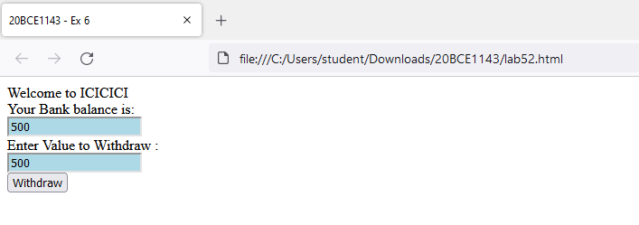

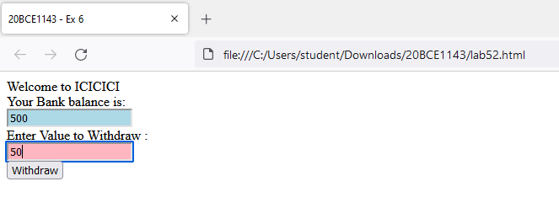

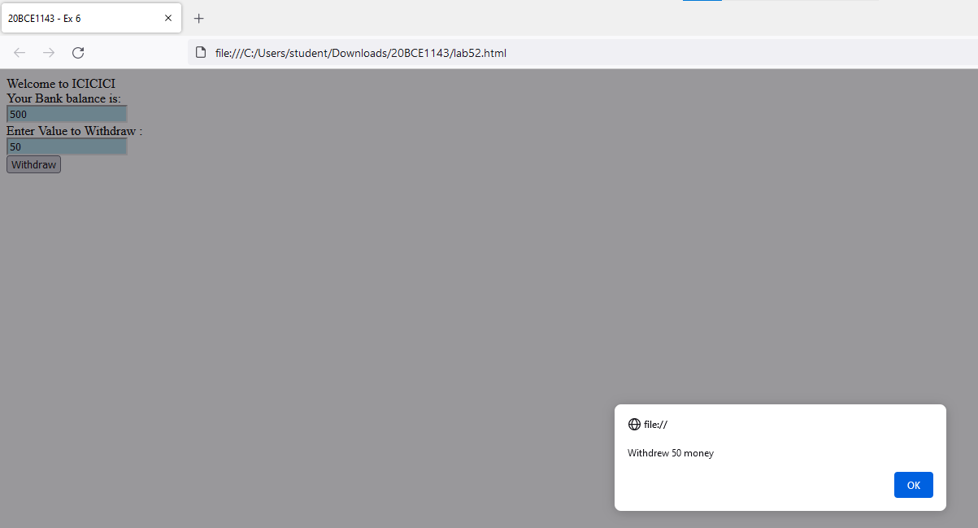

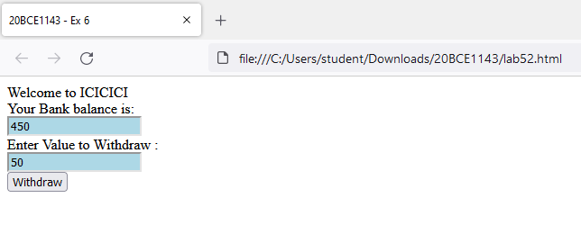

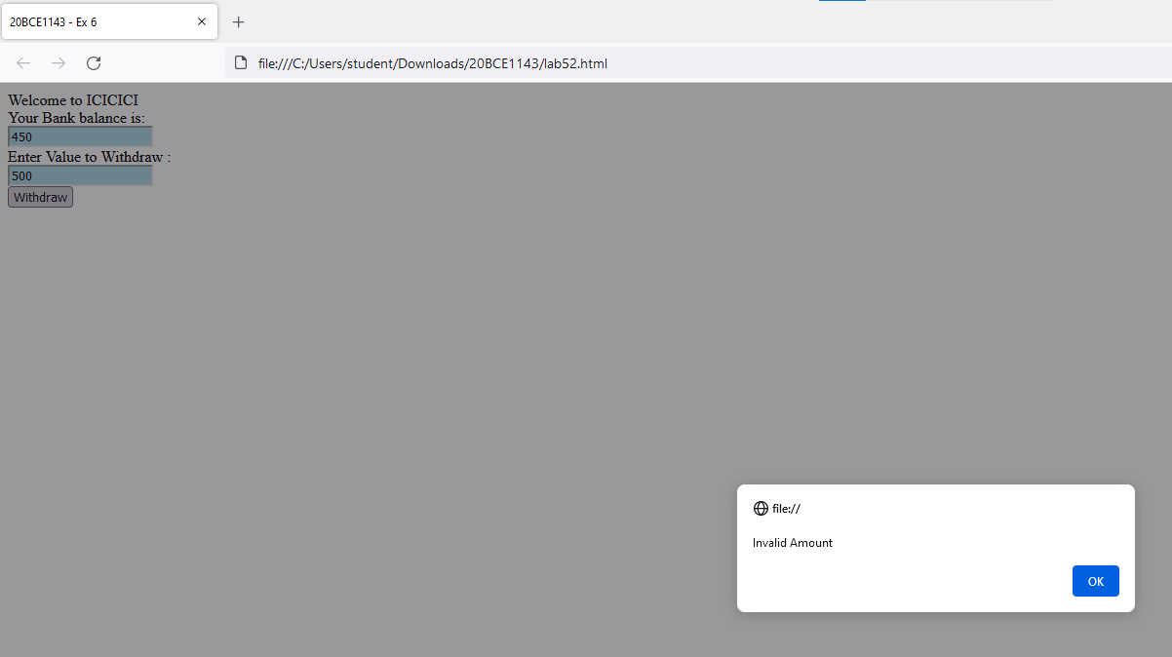

Code:

<head>

    <title>20BCE1143 - Ex 6</title>

    <style>

        input{

            background-color: lightblue;

        }

        input:focus{

            background-color: lightpink;

        }

    </style>

</head>

<body>

    Welcome to ICICICI

    <br>

    Your Bank balance is: <br>

    <input type="text" id="bal" readonly>

    <script>

        document.getElementById("bal").value="500";

    </script>

    <br>

    Enter Value to Withdraw : <br>

    <input type="text" id="val" onkeyup="this.value = this.value.replace(/[^0-9]/, '')">

    <br>

    <button onclick="myfun()">Withdraw</button>

    <script>

        function myfun(){

            var x=document.getElementById("val").value;

            var y=document.getElementById("bal").value;

            if(y>x)

            {

                alert("Withdrew "+x+" money");

                document.getElementById("bal").value=(y-x);

            }

            else

                alert("Invalid Amount");

        }

    </script>

</body>

1. Design the **below form** and do the following
2. Set the timer to display the current time
3. Print the form content
4. Use getElemnetsByName to display Gender, Country and Preferences
5. Validate
6. All Mandatory Fields (represented by *)
7. Name should not exceed 15 characters
8. Address – to be specified in Text Area
9. Zip code should be numeric and validated the maximum digits
10. Phone numbers should be numeric and validated the maximum digits 10
11. e-mail syntax should be validated
12. Password should contain a number, character & a special character and length should not exceed 15 and recede 8
13. PAN card number – Textbox (validate such that the PAN number is 10 digits and follows the pattern)

|  |
| --- |
| https://www.ntu.edu.sg/home/ehchua/programming/webprogramming/images/JS_FormValidation.png  Time:11:30:55  Pan No: |

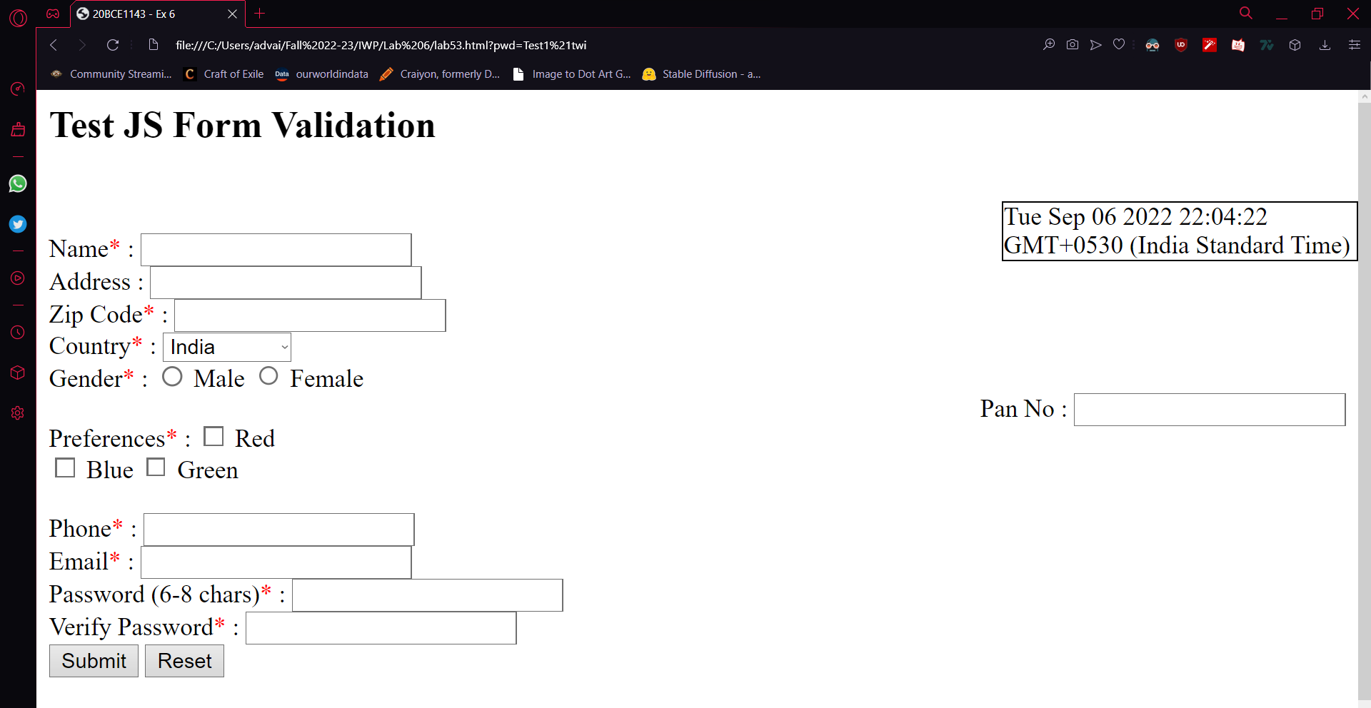

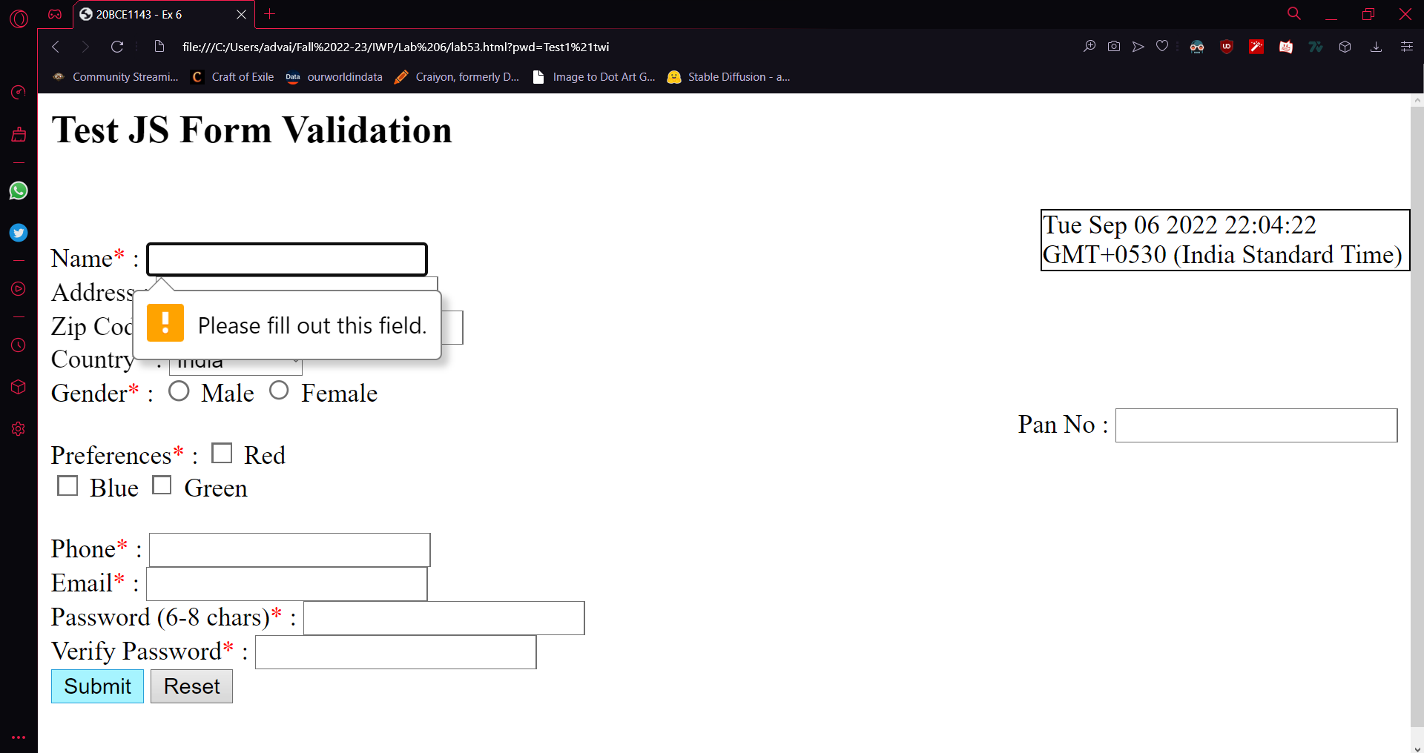

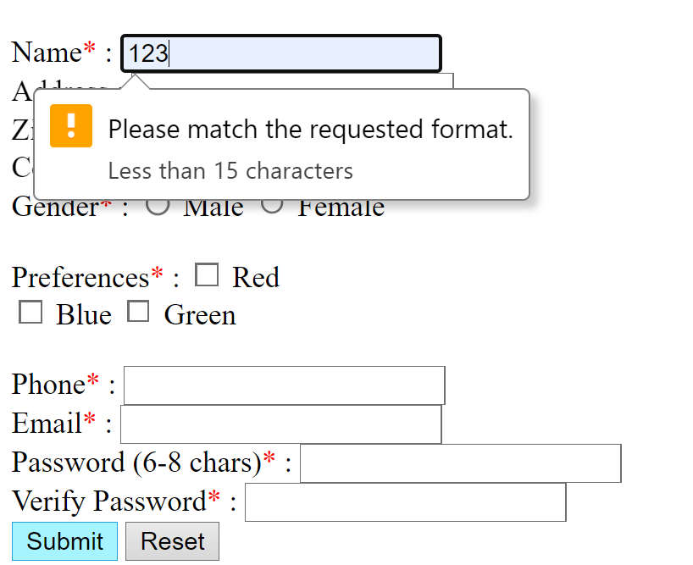

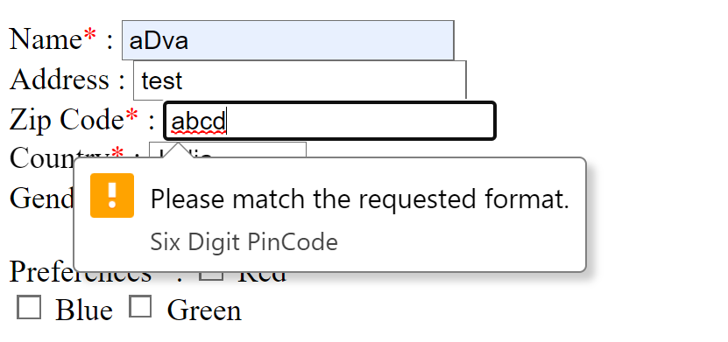

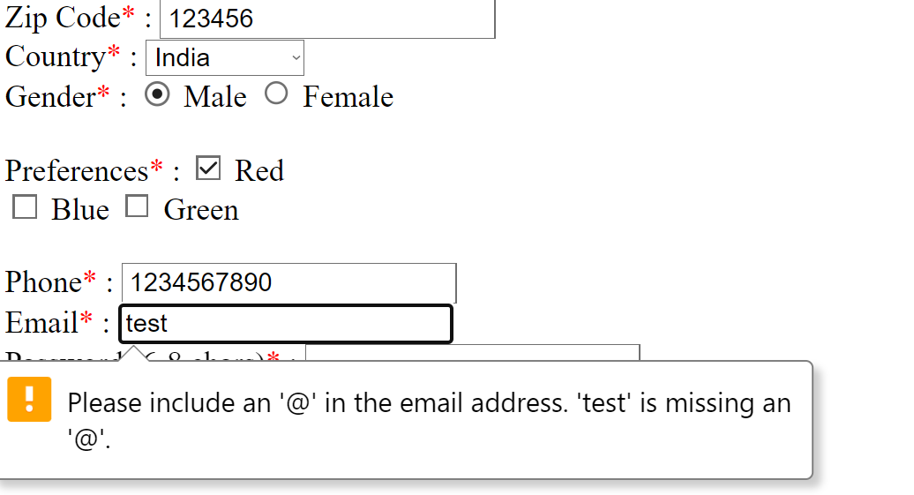

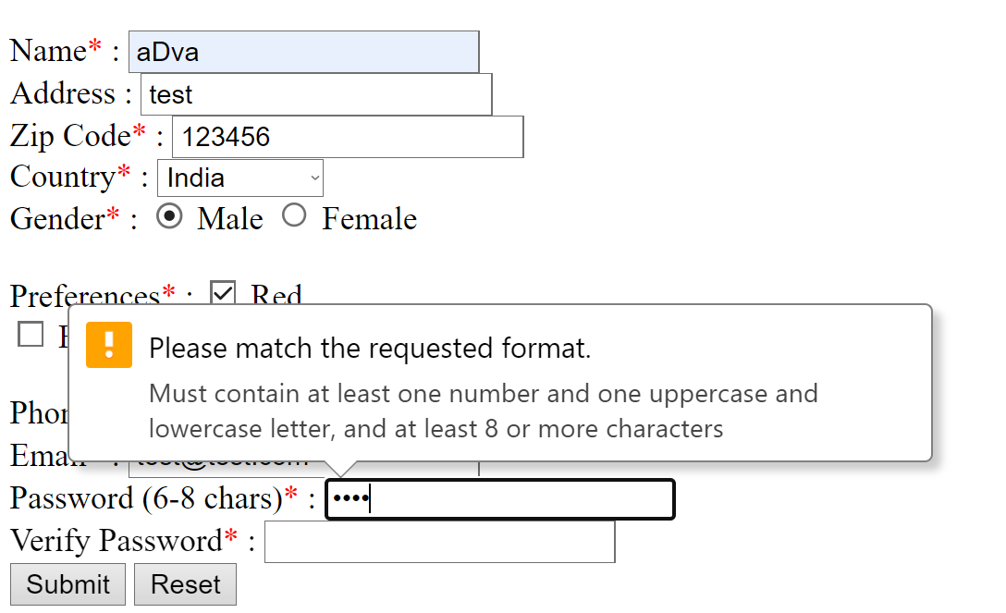

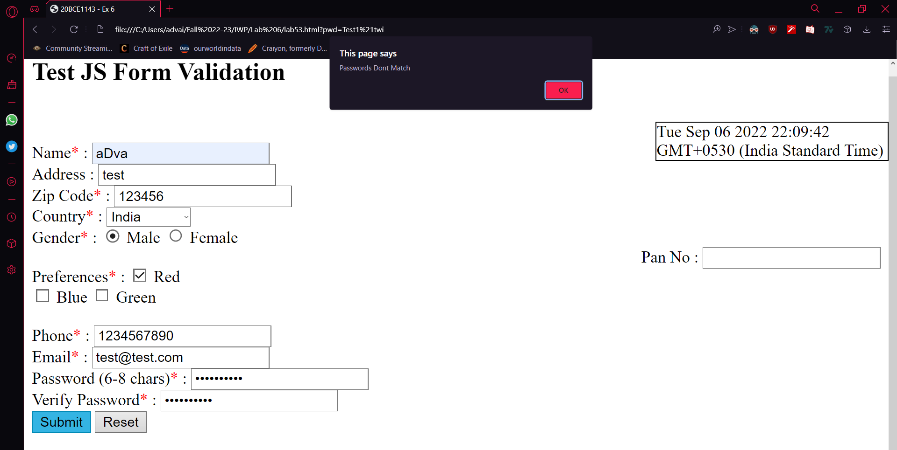

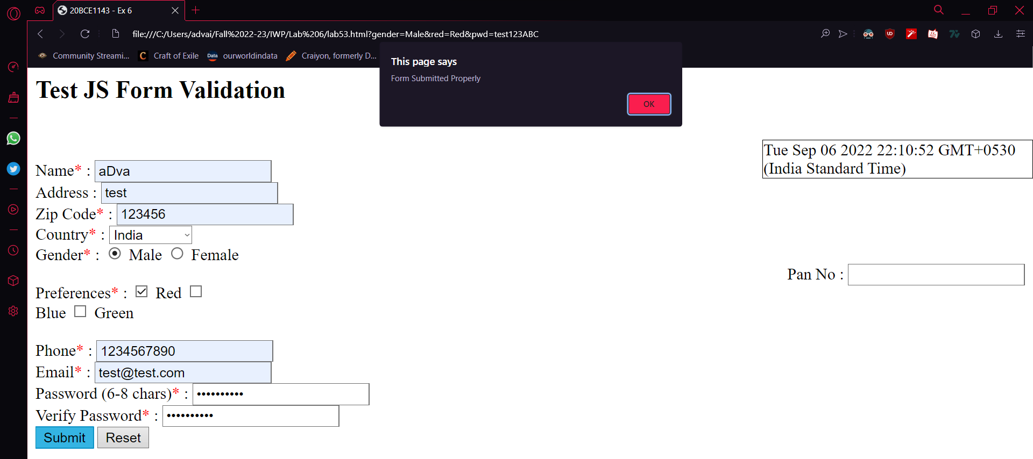

Code:

<head>

<title>20BCE1143 - Ex 6</title>

</head>

<body>

<h2>Test JS Form Validation</h2>

<p style="border:1px solid black;width:26.7%;position:absolute;right:0px;" id="demo">

</p>

<script>

var d = new Date();

document.getElementById("demo").innerHTML=d;

</script>

<br>

<br>

<form>

Name<font color="red">*</font> :

<input type="text" id="name" pattern="[a-zA-Z\s]{1,15}" title="Less than 15 characters" required>

<div id="namefill" style="color: red;float:right;margin-right:80%;"></div>

<br>

Address :

<input type="textarea" id="adr">

<div id="areafill" style="color: red;float:right;margin-right:80%;"></div>

<br>

Zip Code<font color="red" >*</font> :

<input type="text" id="zip" pattern="[0-9]{6}" title="Six Digit PinCode" required>

<div id="zipfill" style="color: red;float:right;margin-right:80%;"></div>

<br>

Country<font color="red">*</font> :

<select id="country" required>

<optgroup label="--select a country--">

<option value="India">India</option>

<option value="America">US of A</option>

</optgroup>

</select>

<div id="countryfill" style="color: red;float:right;margin-right:80%;"></div>

<br>

Gender<font color="red">*</font> :

<input type="radio" id="male" name="gender" value="Male" required>

<label for="male">Male</label>

<input type="radio" id="female" name="gender" value="Female">

<label for="female">Female</label><br>

<div style="float:right">

Pan No :

<input type="text" id="pano" pattern="([A-Z]{5}[0-9]{4}[A-Z]{1})" title="Your Pan Number">

<div id="panfill" style="color: red;float:right;margin-right:80%;"></div>

</div>

<div id="genderfill" style="color: red;float:right;margin-right:80%;"></div>

<br>

Preferences<font color="red">*</font> :

<input type="checkbox" id="red" name="red" value="Red">

<label for="red"> Red</label>

<input type="checkbox" id="blue" name="blue" value="Blue">

<label for="blue"> Blue</label>

<input type="checkbox" id="green" name="green" value="Green">

<label for="green"> Green</label>

<br>

<div id="colfill" style="color: red;float:right;margin-right:80%;"></div>

<br>

Phone<font color="red">*</font> :

<input type="text" id="phno" pattern="[0-9]{10}" title="10 digit ph no" required>

<div id="phfill" style="color: red;float:right;margin-right:80%;"></div>

<br>

Email<font color="red">*</font> :

<input type="email" id="email" required>

<div id="emailfill" style="color: red;float:right;margin-right:80%;"></div>

<br>

Password (6-8 chars)<font color="red">*</font> :

<input type="password" id="pwd" name="pwd" pattern="(?=.*\d)(?=.*[a-z])(?=.*[A-Z]).{8,}"

title="Must contain at least one number and one uppercase and lowercase letter, and at least 8 or more characters" required>

<div id="pwdfill" style="color: red;float:right;margin-right:80%;"></div>

<br>

Verify Password<font color="red">*</font> :

<input type="password" id="vpwd" required>

<div id="vpwdfill" style="color: red;float:right;margin-right:80%;"></div>

<br>

<input type="submit" onclick="myfun()">

<input type="reset">

</form>

<br>

<script>

function myfun(){

if(document.getElementById("pwd").value==document.getElementById("vpwd").value)

{

alert("Form Submitted Properly");

}

else

{

alert("Passwords Dont Match");

}

}

</script>

</body>